write FULL paper title here

A template and guidelines for authors- any subtitle – 20 words maximum both main and subtitles

Author fAMILY NAME. A1, Author FAMILY NAME. B1* and AUTHOR FAMILY NAME. C2

1,First institution, Then city, Then country

Email of first author@first institute

*Email of second and corresponding author@first institute

2Second institution, Second city, Second country

Email of third author@second institute

(Do not identify the author details such as names, affiliations in any part of the paper including acknowledgements. Write the names of authors, affiliations and contact emails when submitting the camera-ready paper after reviewer comments, Add * to identify the corresponding author)

**Abstract.** The abstract should be in one paragraph. It should explain the research context, issues investigated, the methodology used, and key findings discussed. The abstract should be without any citation, references and unexplained abbreviations and has not more than 200 words. [Cambria 08, Line spacing: 1.5 lines, Paragraph Space Before: 12pt, After:6 pt ]

Keywords. Five keywords - maximum

1. Introduction – this is an essential section of the paper (Cambria 11, bold)

This paper should commence with an introduction to the work. In addition, the paper should include sections for research methodology, findings, a conclusion, and list of references.

Left indent when starting a paragraph except the first paragraph of all sections, sub sections etc. Submit your full-paper for review as a MS Word-file, which shall include images with a high resolution using this template.

2. Heading Level 1 for main sections (Cambria 11, bold)

It is recommended to have at least one paragraph of text underneath each heading. The maximum number of pages should be 12 including images and references – when formatted with this template. Submit your print ready final paper in word format.

Left indent when starting a paragraph except the first paragraph of all sections, sub sections etc. There are no footers.

2.1. Sub-heading – level 2

This is a second level heading style. Font: Cambria CAPITAL. Use a spelling checker and a grammar checker. Format your paper simply to look like this document. Limit the number of pages to 12.

*2.1.1 Sub-heading – Level 3*

Use this format Cambria 10 *Italic* for any sub-headings of level 3. The font size will remain as of the other text. Space before: 14 pt. Space after: 10 pt.

*2.1.2 Sub-heading – Level 3*

Use this format Cambria 10 *Italic* for any sub-headings of level 3. The font size will remain as of the other text. Space before: 14 pt. Space after: 10 pt.

3. Bullet Points

There has to be at least one paragraph after a heading or sub-heading. Leave one line between two paragraphs.

3.1. Sub-heading – level 2

There has to be at least one paragraph after a heading or sub-heading. Leave one line between two paragraphs.

3.2. Sub-heading – level 2

There has to be at least one paragraph after a heading or sub-heading. Leave one line between two paragraphs.

Bullet points can be included in the paper. They can either be separated from the text preceding or following. Same format as body text but with a left indent of 0.5cm. Do not leave one line when you want to include bullet point.

* Bullet point 1
* Bullet point 2
* Bullet point 3

Leave one line to continue the paragraph after bullet points.

4. Figures, Tables and Equations

4.1 FIGURES

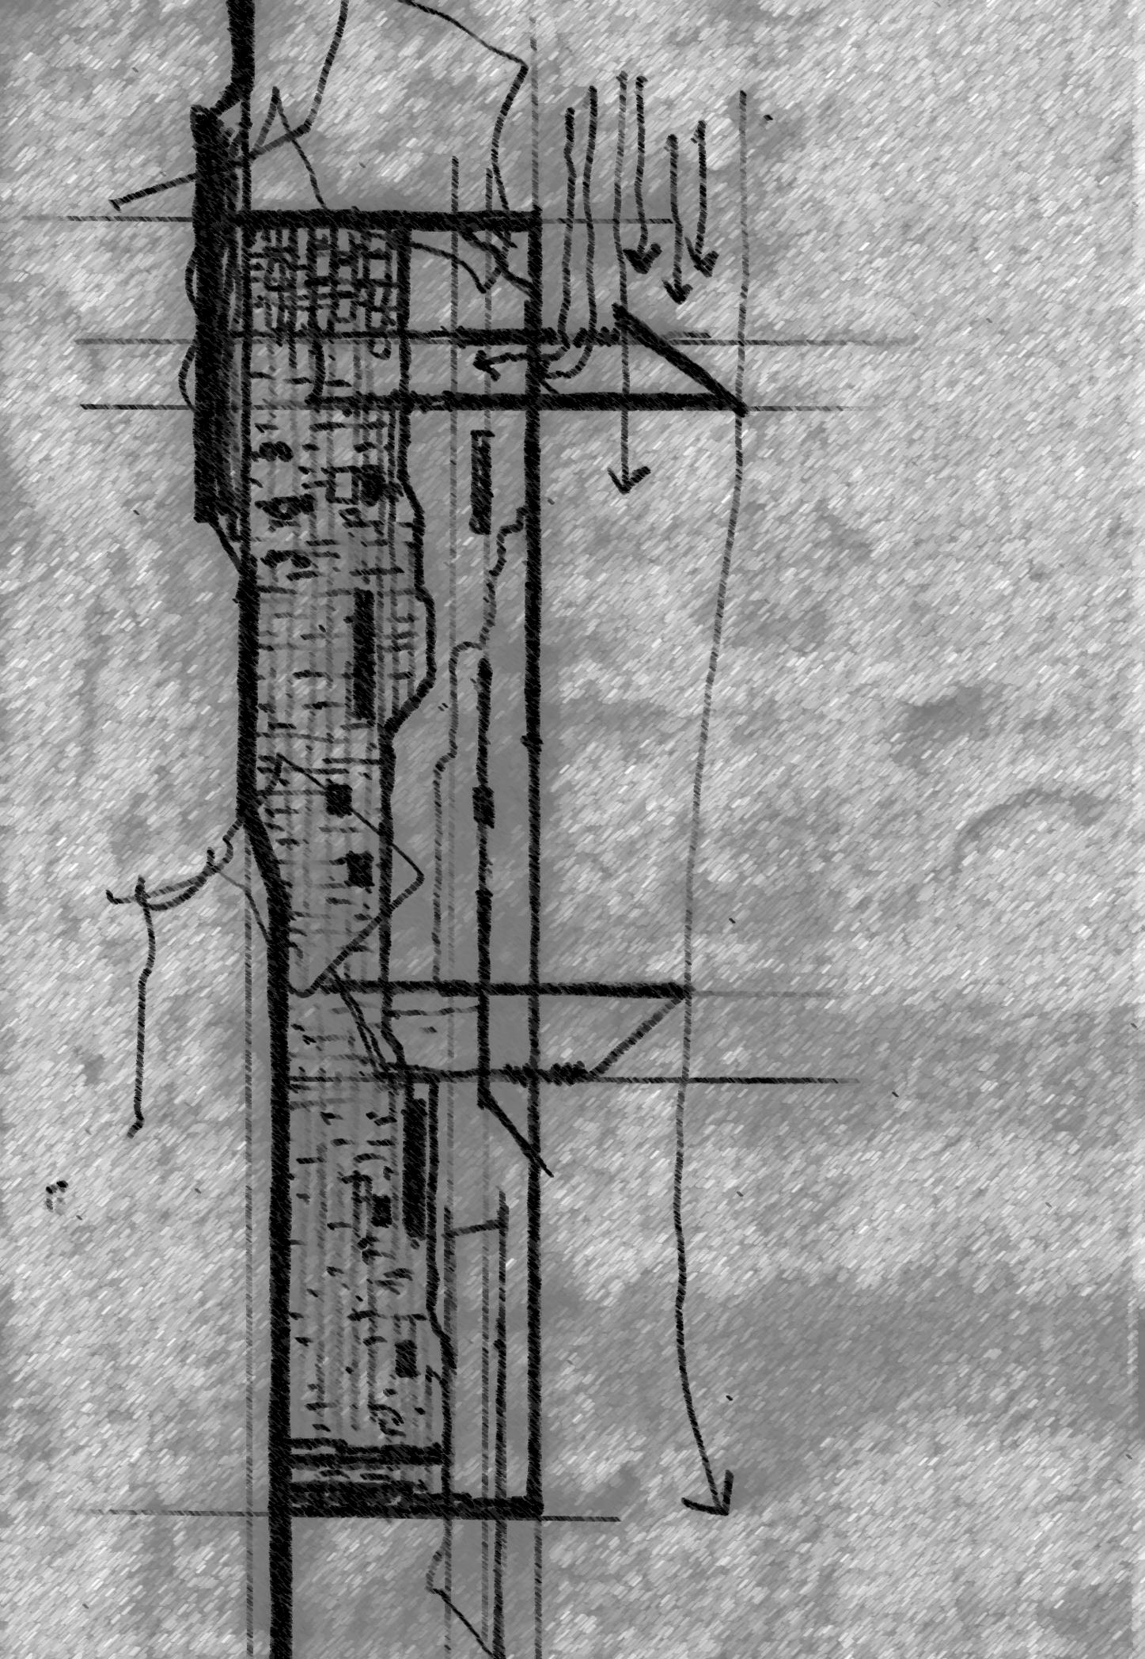Figures should be described appropriately in the text after cross-referencing it in the relevant text. The Figure should have one line of space before the figure and after the caption (except at the end of a section). Do not leave a space between the image and the caption. The caption of the figure should be just below the figure.

Figure and figure caption can be aligned to centre. Full paper manuscripts should contain the Figures. In addition, they shall be separately submitted in high resolution along with the final paper.

Figure 1: Caption should be just below the figure (*Source: Rajapaksha U*)

Use the same formatting as the body text for the figure caption too. Also, try to discuss the figure in the paper by cross referencing as Figure 1 illustrates….

4.2 TABLES

Tables should be described appropriately in the text after cross-referencing it in the relevant text. The Table should have one line of space before the caption and after the table. Do not leave a space between the table caption and table. The caption for a Table should be inserted just above the table.

Table and Table caption can be aligned to centre. Full paper manuscripts should contain the Tables.

Table 1: Caption (*Source: If applicable)*

|  |  |  |  |
| --- | --- | --- | --- |
|  |  |  |  |
|  |  |  |  |
|  |  |  |  |
|  |  |  |  |
|  |  |  |  |
|  |  |  |  |

Use the same formatting as the body text for the table caption too. Also, try to discuss the table in the paper by cross referencing as Table 1 discusses….

4.3. Equations

Equations should be numbered in parentheses at the right margin as shown below.

H2 = *x*2*y*2 + R*x*2 + 3D*xy* (1)

5. Citations, References and Acknowledgements

5.1. REFERENCES

APA Reference Style (7th edition) author-date style should be used for this purpose. For APA Reference Style Please refer the guideline provided in the link below

* [APA Reference Style (7th Edition)](https://uom.lk/sites/default/files/lib/files/APA%207th%20User%20Guide_2021_0.pdf)

5.2. Acknowledgements

Any Acknowledgements to be included only when preparing the final camera-ready paper, after the paper got reviewed and accepted. This is mainly to ensure the double-blind peer review process.